**Principles of Database Management Systems Pl SQL commands Prashanth.S(19MID0020)**

**1) To check whether a person is male or female**

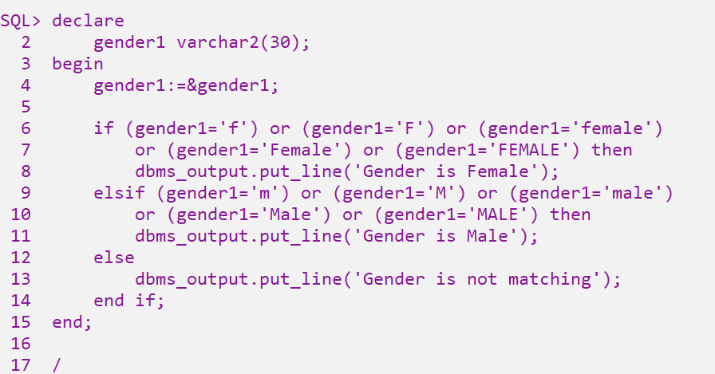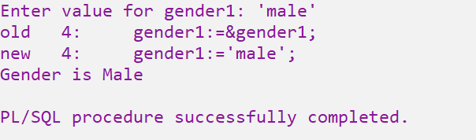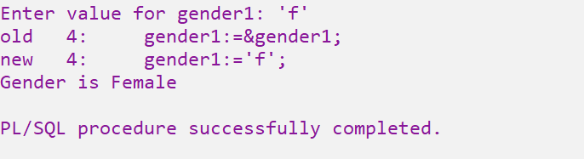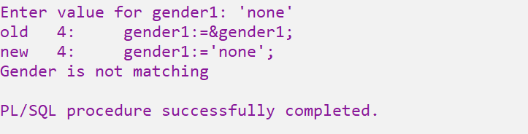

**2) To check whether a person is major/minor**

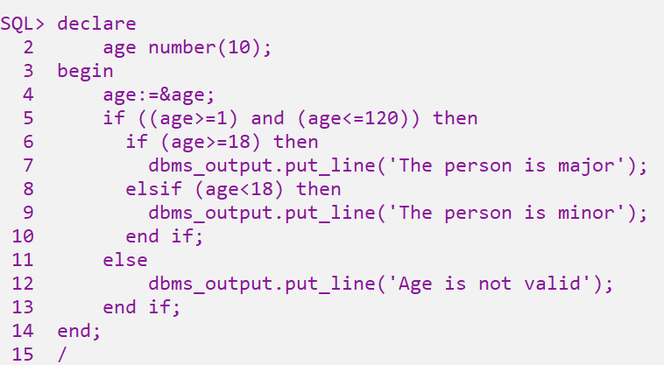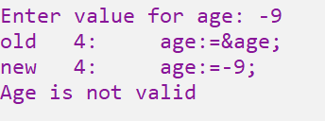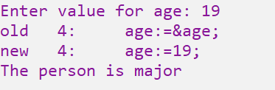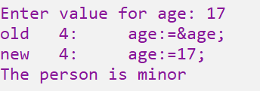

**3) To check whether a student attained ‘S’ grade or not**

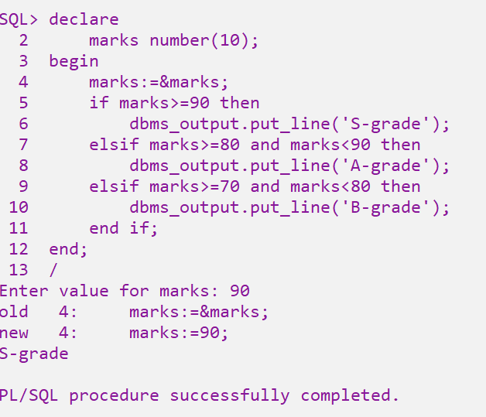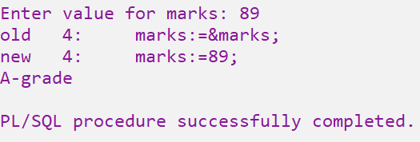

**4) To check whether a person is senior citizen/not**

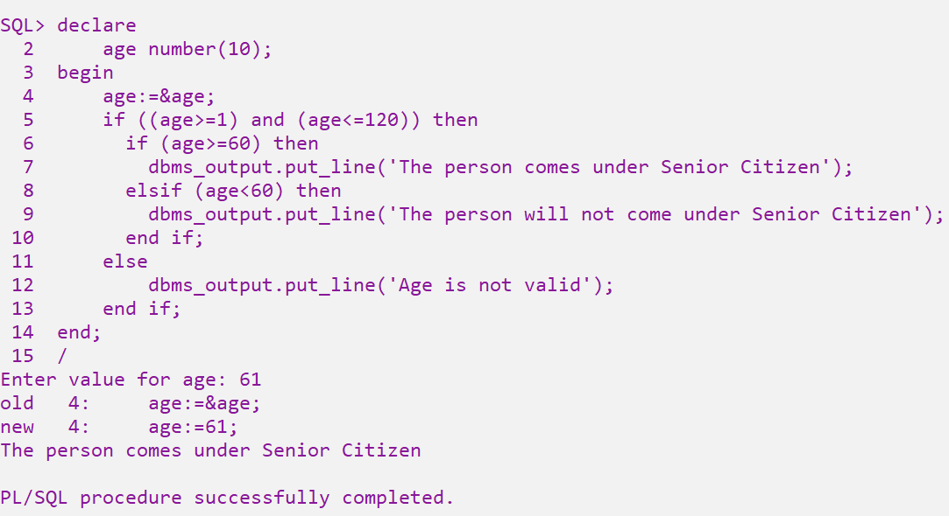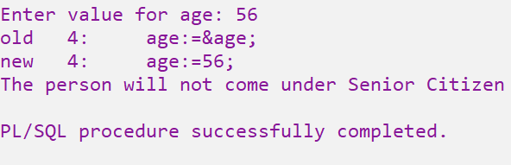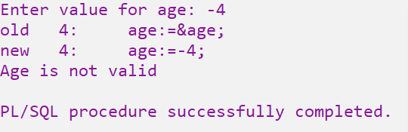

**5) To check whether a student is fail/not**

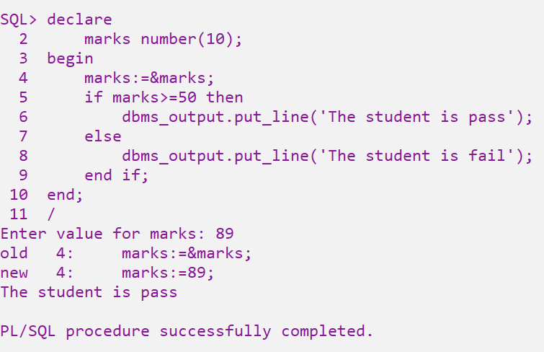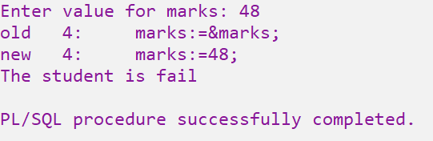

**6) To display grade of student based on the CGPA**

**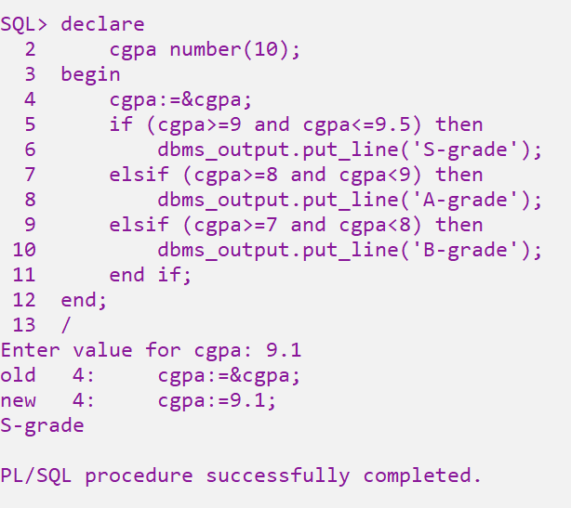  
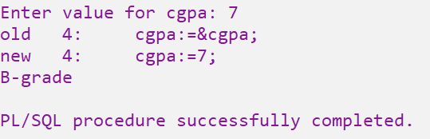**

**7) To find the smallest of the three integer numbers**

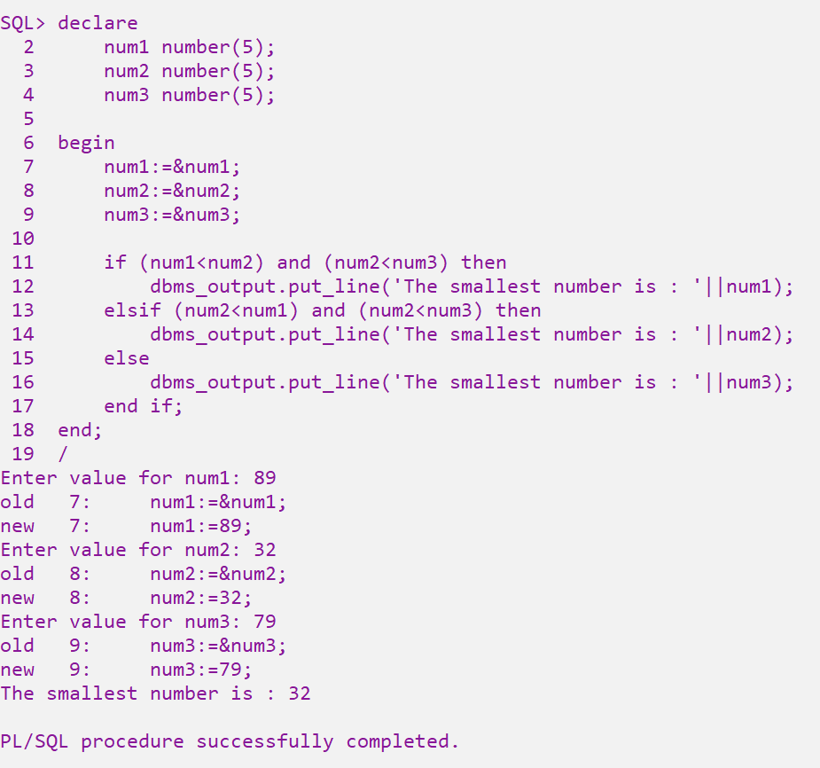

**8) To display cadre of an employee based on his basic pay**

**Basic Pay(Rs.) Cadre**

**25000 Senior Prosser**

**20000 Professor**

**15000 Assistant Professor**

**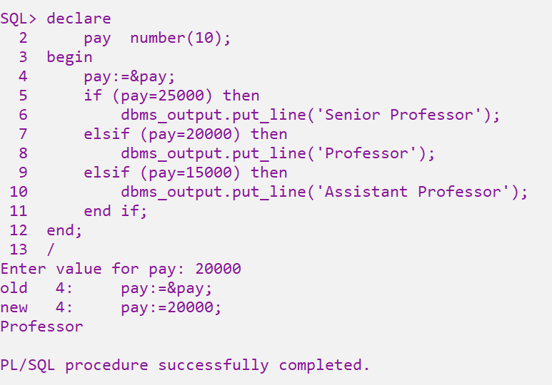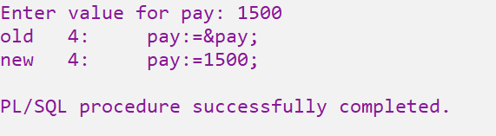  
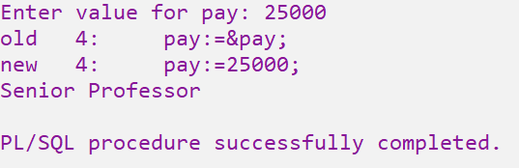**

**9) To find the sum of the digits of given ‘n’ digit integer number**

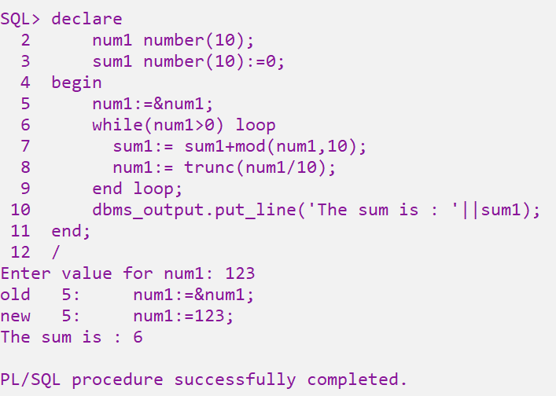

**10) To find the factorial of number between certain range**

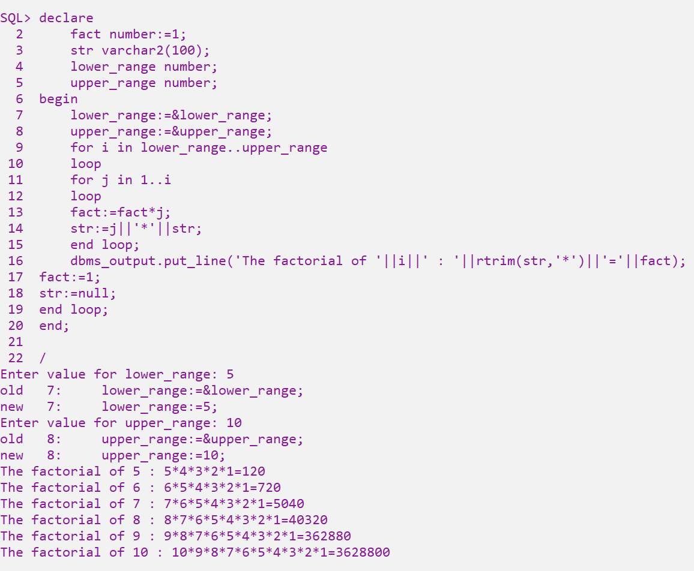

**11) To check whether a given integer is palindrome/not**

